Predicate Pronoun (as Subject Complement)

✅ What Is a Predicate Pronoun?
# Source: AI Source: Provided by: [Data Path: Persons Table -> ID Column: 1, Name_En Column: Motasem Essam] -> From: [ChatGPT] on [8/4/2025]
A predicate pronoun is a type of predicate nominative. It occurs when a pronoun (rather than a noun) is used as a subject complement. Like all predicate nominatives, it follows a linking verb and renames or identifies the subject.
🟨 In short: A predicate pronoun is just a pronoun functioning as a predicate nominative.

🔸 Key Features:
# Source: AI Source: Provided by: [Data Path: Persons Table -> ID Column: 1, Name_En Column: Motasem Essam] -> From: [ChatGPT] on [8/4/2025]
- Follows a linking verb
(is, are, was, were, be, become, seem, etc.)
- Is a subjective case pronoun (I, he, she, we, they)
- Renames or identifies the subject
- Never uses objective case pronouns (me, him, her, us, them)

🔸 Examples of Predicate Pronoun as Subject Complement:
# Source: AI Source: Provided by: [Data Path: Persons Table -> ID Column: 1, Name_En Column: Motasem Essam] -> From: [ChatGPT] on [8/4/2025]
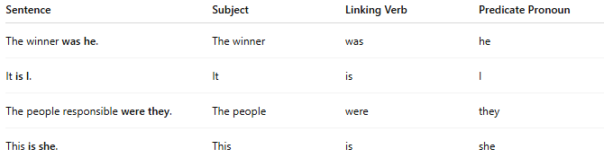
Sentence | Subject | Linking Verb | Predicate Pronoun
The winner was he. | The winner | was | he
It is I. | It | is | I
The people responsible were they. | The people | were | they
This is she. | This | is | she

🔸 Common Mistake to Avoid:
# Source: AI Source: Provided by: [Data Path: Persons Table -> ID Column: 1, Name_En Column: Motasem Essam] -> From: [ChatGPT] on [8/4/2025]
❌ "It is me." (colloquial but incorrect in formal grammar)
✅ "It is I." (formal grammar – correct subjective case)

🔹 Summary:
# Source: AI Source: Provided by: [Data Path: Persons Table -> ID Column: 1, Name_En Column: Motasem Essam] -> From: [ChatGPT] on [8/4/2025]
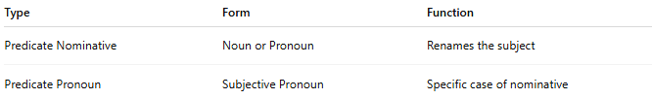
Type | Form | Function
Predicate Nominative | Noun or Pronoun | Renames the subject
Predicate Pronoun | Subjective Pronoun | Specific case of nominative

